The People’s Republic of China

Utilizing ADB Loan

Multimodal Passenger Hub and Railway Maintenance Project

Procurement of High Speed Railway Wrecking Crane
Clarification Reply & Addendum of Bidding Document No.1

Issued On: September 19, 2025
ICB No.: 0702-2520CITC7029
Lot No.: LM-1
The Purchaser: China State Railway Group Co., Ltd. and Chengdu-Kunming Railway Co., Ltd.
Procurement Agent: CMC International Tendering Co., Ltd.
Country: P. R. China
INSTRUCTION

To whom it may concern:

According to the requirement of ITB 7 of Bidding Document, for details as follows:
7.1 A prospective Bidder requiring any clarification on the Bidding Document shall contact the Purchaser in writing at the Purchaser’s address indicated in the BDS. The Purchaser will respond in writing to any request for clarification, provided that such request is received no later than 21 days prior to the deadline for submission of Bids. The Purchaser shall forward copies of its response to all Bidders who have acquired the Bidding Document, including a description of the inquiry but without identifying its source. Should the Purchaser deem it necessary to amend the Bidding Document as a result of a clarification, it shall do so following the procedure.
According to the requirements of the Purchaser, we hereby issue the Clarification Reply & Addendum of Bidding Document No.1 to all Bidders who have purchased Bidding Document of Lot LM-1.
Your written confirmation of this Clarification Reply by E-mail before 5:00 p.m. X September 2025 is highly appreciated.

Contact Person: Ms. Zhou Jing; Mr. Shi Zehua
E-mail: zhoujing15@cgci.gt.cn; shizehua@cgci.gt.cn
Tel: 010-81168502; 010-81168451

CMC International Tendering Co., Ltd.
September 19, 2025
1. 问题1
“一.高速铁路救援起重机的 2 主要特点”中，2.2条款“高铁线路上救援最大起重力矩1125t∙m”建议改为“高铁线路上救援最大起重力矩≥1125t∙m”。
理由：在符合TB/T3081-2017《铁路救援起重机技术条件》及TB/T3081-2017《铁路救援起重机技术条件》第1号修改单的条件下，不限制高铁线路上的救援能力。
QUESTION:
In item 2.2 of "2.Main Characteristics of I.Rescue Crane of High-Speed Railway ", the phrase "The maximum load moment for rescue on the high-speed railway is 1125t∙m" is changed to "The maximum load moment for rescue on the high-speed railway is ≥1125t∙m".
Reason: Under the conditions of complying with TB/T3081-2017 《Technical Specification for Railway Rescue Crane》and TB/T3081-2017《Technical Specification for Railway Rescue Crane》Amendment No. 1, the technical proposal of the railway crane should not be restricted.

回复：同意修改。使描述更加准确，同时将原技术规格书参数做以下修改：（1）2.2条改为：最大起重量≥125t，最大起重力矩≥1250t∙m；高铁线路上救援最大起重力矩≥1125t∙m，最高回送速度≥120km/h。
Reply：Agree to modify. To make the description more accurate, the following modifications are made to the parameters of the original technical specifications: (1) Article 2.2 is changed to: The maximum load capacity is ≥125t, and the maximum load moment is ≥1250t ∙ m; The maximum load moment for rescue on the high-speed railway is ≥1125t ∙ m, and the slewing speed is ≥120km/h.
（2）5.3.1 工作速度中“回送速度 120km/h”修改为“最高回送速度≥120km/h”。
(2) " slewing speed is 120km/h" in 5.3.1 Working Speed is changed to " Max. slewing speed is ≥120km/h".

2. 问题2
“一.高速铁路救援起重机的 2 主要特点”中，2.3条款删除“采用伸缩支腿、多支腿承载及辅助支撑技术”。
理由：在符合TB/T3081-2017《铁路救援起重机技术条件》及TB/T3081-2017《铁路救援起重机技术条件》第1号修改单的条件下，不限制具体技术路线。
QUESTION:
In item 2.3 of the "2.Main Characteristics of I.Rescue Crane of High-Speed Railway ", delete the phrase “The rescue crane adopts telescopic outriggers, multiple outriggers for loading capacity and auxiliary support technology”。
Reason:1.Under the conditions of complying with TB/T3081-2017 《Technical Specification for Railway Rescue Crane》and TB/T3081-2017 《Technical Specification for Railway Rescue Crane》Amendment No. 1, the capacity of the railway crane should not be restricted.

回复：不同意修改。原条款符合TB/T3081-2017对于相关支腿的规定，本技术要求允许其它技术路线，但须满足TB/T3081-2017的规定。
Reply：Disagree. The original clause complies with the provisions of TB/T3081-2017 for relevant support. Other technical scheme are allowed in this technical requirement, but they must meet the requirements of TB/T3081-2017.

3. 问题3
“一.高速铁路救援起重机的4 适应的工作环境”中，4.6条款：“限界符合GB146.1-2020《标准轨距机车车辆限界》”改为“限界符合GB146.1-2020《标准轨距铁路限界 第1部分：机车车辆限界》”。
理由：修改文字错误。
QUESTION:
In the "4 Adapted Working Environment of I. Rescue Crane of High-Speed Railway" section, item 4.6: "Gauge Comply with GB146.1-2020《Rolling Stock Gauge for Standard Gauge Railways》is changed to “Gauge Comply with GB146.1-2020 《Rolling Stock Gauge for Standard Gauge Railways- Part 1: Rolling Stock gauge》”.
Reason: Correction of text errors

回复：同意修改。按TB/B3081-2017描述修改为“限界符合GB146.1-2020《标准轨距铁路限界 第1部分：机车车辆限界》”。
Reply：Agree to modify. According to the description in TB/B3081-2017, it is changed to "Comply with GB146.1-2020 Standard Gauge Railway Clearance - Part 1: Rolling stock Clearance".

4. 问题4
“一.高速铁路救援起重机的 5 主要性能及参数”中，5.2.1条款的“表1 主要起重性能”的第5列：表头“支腿/辅助支腿/辅助支撑”改为“跨距”，工况1中及工况2删除“（单侧）”，工况3及工况4删除“辅助支撑”，工况5删除“辅助支腿”。
理由：(1).在符合TB/T3081-2017《铁路救援起重机技术条件》及TB/T3081-2017《铁路救援起重机技术条件》第1号修改单的条件下，不限制具体技术路线。
(2).查看TB/T3081-2017《铁路救援起重机技术条件》，未见“单侧”支腿定义，我方理解“单侧”支腿作业是指在高铁双线桥梁上作业时，起重机依靠自身转向架站在其中一条线路上，起重机的一侧两条支腿展开并支撑在另一条线路的中心线上，在该状态下，“跨距5m”是指从起重机中心线到支撑在另一条线路上支腿垂直油缸中心线且垂直于线路方向上的距离，如图1中的5000mm。在这种状态下，起重机的作业回转区域为30°，如图1所示。
(3).将起重机移到两条线路中间，起重机的四条支腿分别支撑在两条铁路线路的中心线上，在该状态下，“跨距5m”为支撑在两条铁路线路上的支腿垂直油缸中心线且垂直于铁路线路方向上的距离，如图2中的5000mm。这种状态下，起重机回转作业区域可由30°增加为60°，回转区域增大，同时能满足桥梁承载能力受限的问题；在适当的幅度下，起重机还可以带载进行360°回转作业，如图3所示；因此，“跨距5m（单侧）”支腿作业方式属于强制性条款，限制了起重机的具体技术路线。
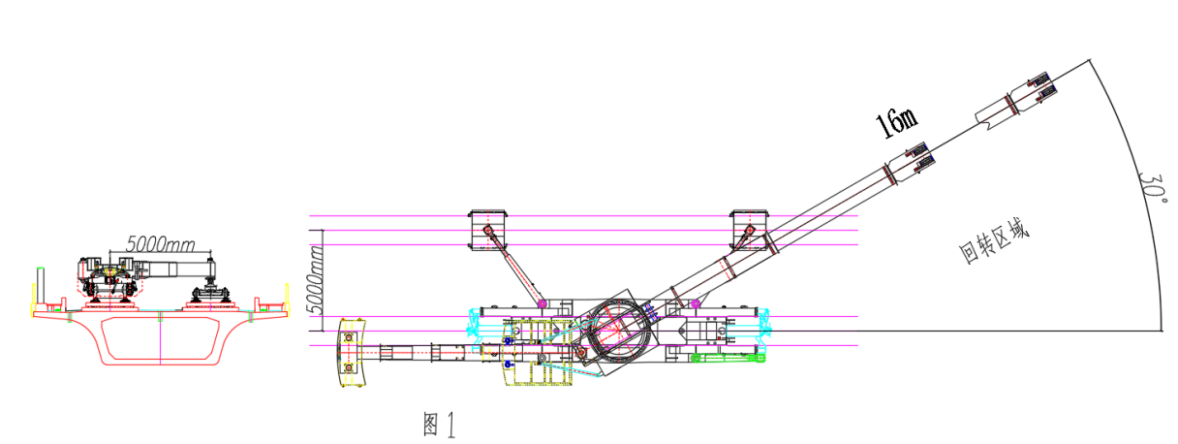
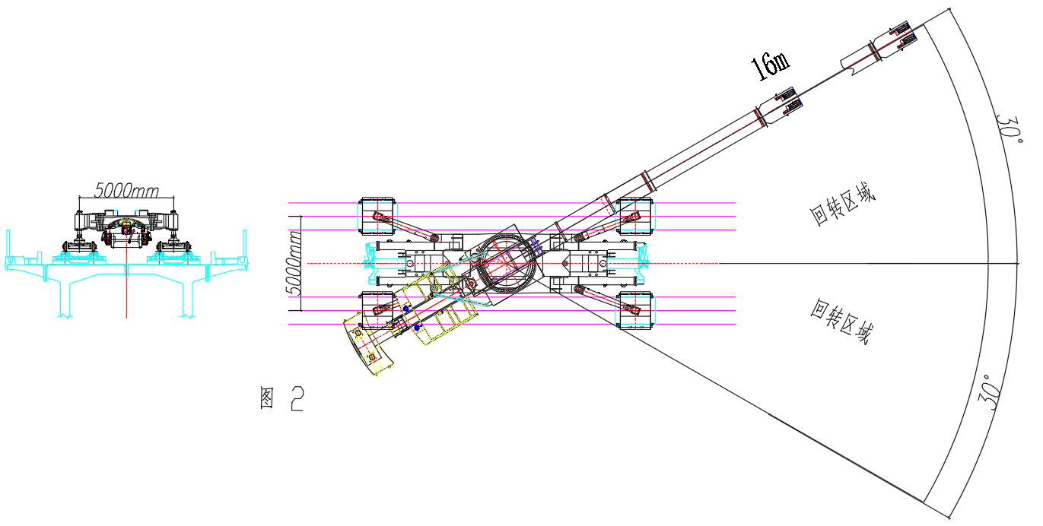
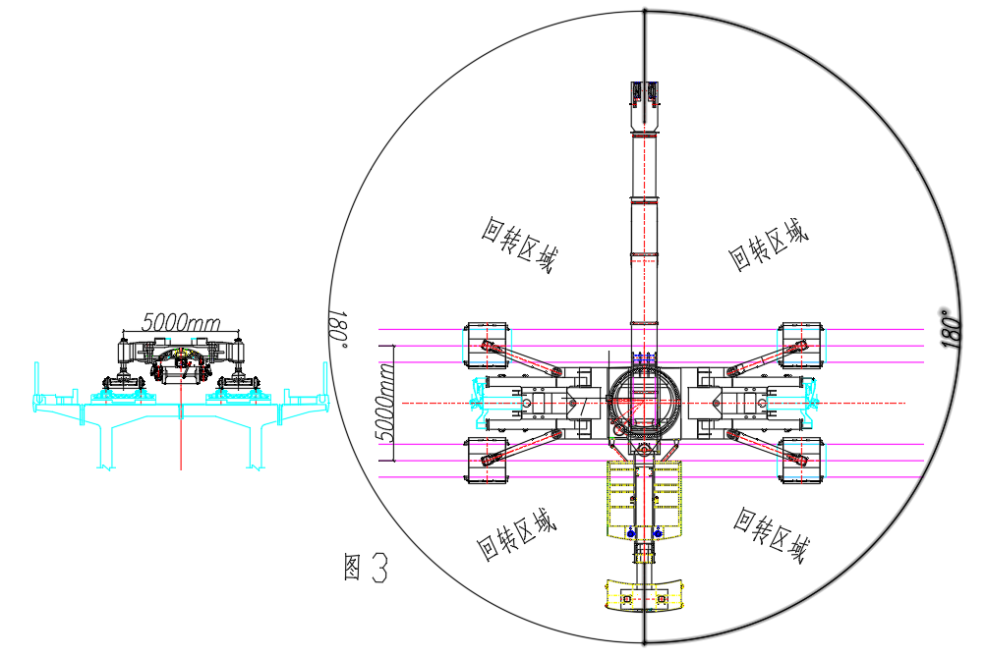
QUESTION:
In the "5 Main Performance and Parameters of I .Rescue Crane of High-Speed Railway", in item 5.2.1, the fifth column of "Table 1 Main Lifting Performance": the header "Leg/Auxiliary Leg/Auxiliary Support" is changed to "Span", "(single-sided)" is deleted in working condition 1 and working condition 2, "Auxiliary Support" is deleted in working condition 3 and working condition 4, and "Auxiliary Leg" is deleted in working condition 5.
Reason:（1）.Under the conditions of complying with TB/T3081-2017 《Technical Specification for Railway Rescue Crane》and TB/T3081-2017 《Technical Specification for Railway Rescue Crane》Amendment No. 1, the technical proposal of the railway crane should not be restricted.
（2）.According to TB/T3081-2017 《Technical Specification for Railway Rescue Crane》, there is no definition of single-sided support legs. Our opinion is that single-sided support leg operation refers to the operation on a high-speed railway double track bridge, where the crane relies on its own bogie to stand on one of the tracks, and the two support legs on the same side of the crane are extended and supported on the center of the other track. In this state, the span of 5m refers to the distance from the center of the crane to the support leg on the other track, which is perpendicular to the center of the oil cylinder and perpendicular to the direction of the track, as shown in Figure 1 at 5000mm. In this state, the working rotation area of the crane is 30°, as shown in drawing 1.
（3）. Move the crane to the middle of two railway lines, with the four legs of the crane supported on the center of the two railway lines. In this state, the span of 5m is the distance between the legs supported on the two railway lines perpendicular to the center of the oil cylinder and perpendicular to the direction of the railway line, as shown in drawing 2 at 5000mm. In this state, the rotation operation area of the crane can be increased from 30 °to 60 °, and the rotation area can be increased, while also meeting the problem of limited bridge bearing capacity; At an appropriate amplitude, the crane can also carry a load for 360° rotation operations, as shown in drawing 3. Therefore, the 5m (single-sided) leg operation method is a mandatory clause that limits the specific technical proposal of the crane.
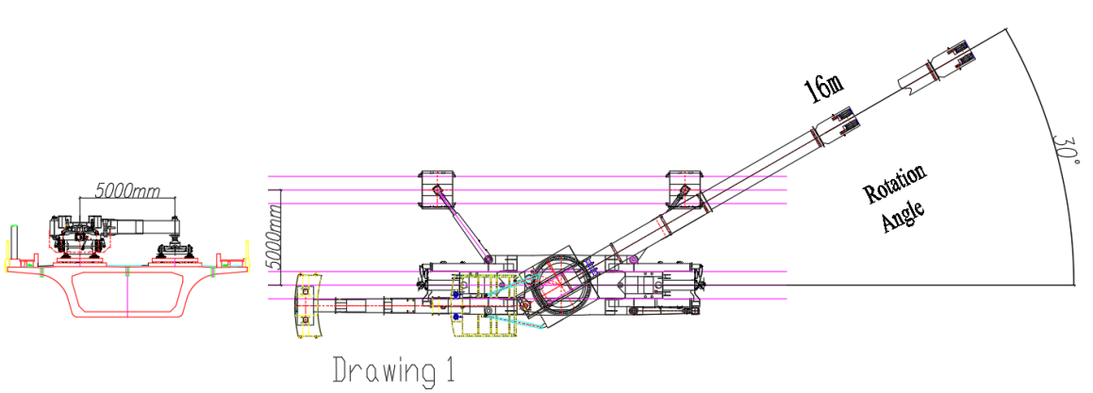
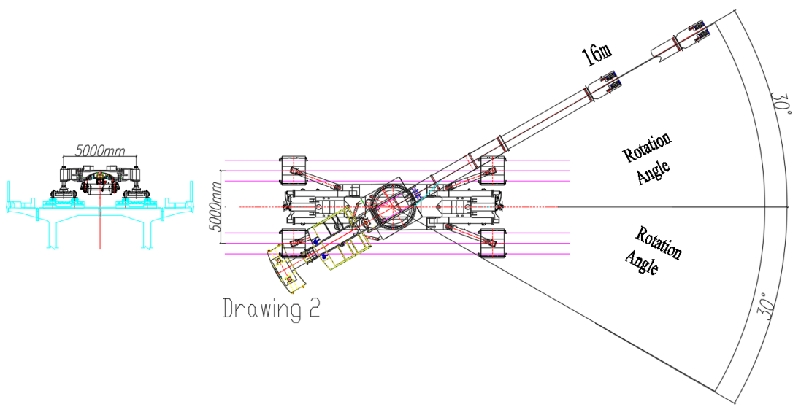
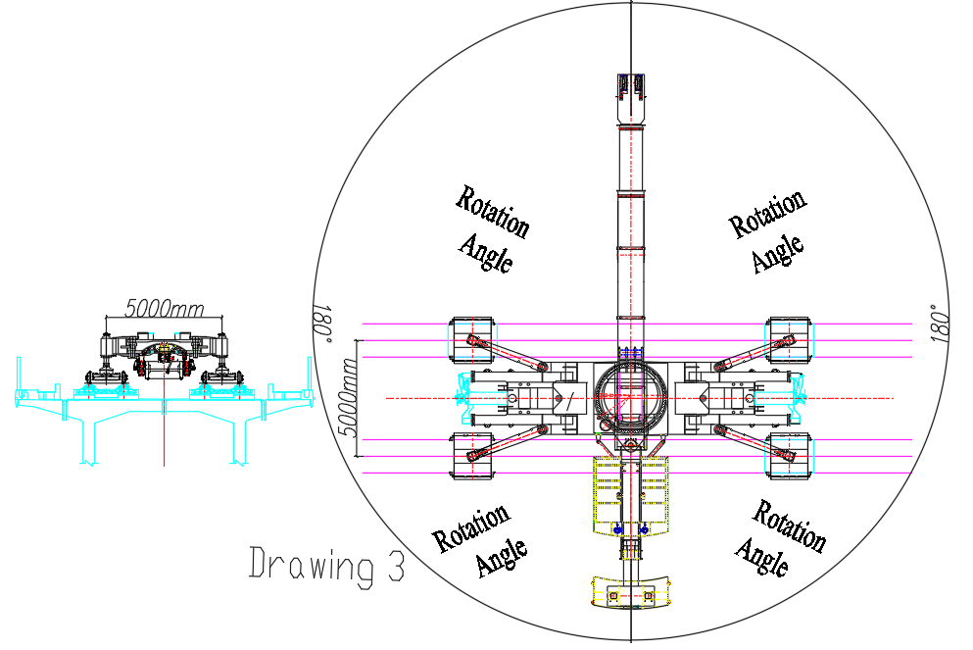

回复：不同意修改。根据救援的实际情况，部分场景支腿支撑条件受限，我们提出单侧支腿距离需满足5m的要求，是考虑当救援起重机在邻线实施救援时，起重机两侧均各自都有5m距离，可满足两个方向救援的工况，而非仅具有一侧5m的救援方式。对于采用不同技术路线（如：起重机横移至两线中间的设计），其满足左右横移总量达到5m时符合“单侧5m”标准，无需修改。同时，如做修改，则不具备起重机横移功能的设计车型将可能因单侧不足5m无法满足高铁救援需要。
Reply：Disagree. According to the actual situation of rescue, the supporting conditions of outriggers in some scenarios are limited. We propose that unilateral outriggers span shall meet the requirement of 5m. This is because when the rescue crane carries out rescue on adjacent tracks, both sides of the crane have a distance of 5m respectively, which can meet the working condition of rescue in two directions instead of only having 5m on one side. For different technical schemes (such as the design of the crane moving horizontally to the middle of the two lines), it meets the "5m on one side" standard when the total amount of left and right movement reaches 5m, and no modification is required. At the same time, if modifications are made, the design model without crane traversing function may not meet the needs of high-speed rail rescue due to less than 5m on one side.

5. 问题5
“一.高速铁路救援起重机的5 主要性能及参数”中，5.3.1条款：“回转速度1.5r/min”改为“回转速度大于或等于1r/min”。
理由：“回转速度1.5r/min”属于限制性条款，建议按照TB/T3081-2017《铁路救援起重机技术条件》中的要求描述；在符合TB/T3081-2017《铁路救援起重机技术条件》及TB/T3081-2017《铁路救援起重机技术条件》第1号修改单的条件下，不限制具体技术路线。
QUESTION:
In the "5 Main Performance and Parameters of I.Rescue Crane of High-Speed Railway", item 5.3.1: "Slewing speed of 1.5r/min" is changed to "Slewing speed greater than or equal to 1r/min"
Reason: "Rotation speed of 1.5r/min" is a restrictive clause, and it is recommended to describe it according to the requirements of TB/T3081-2017 《Technical Specification for Railway Rescue Crane》; Under the conditions of complying with TB/T3081-2017 《Technical Specification for Railway Rescue Crane》 and TB/T3081-2017 《Technical Specification for Railway Rescue Crane》Amendment No. 1, the technical proposal of the railway crane should not be restricted.

回复：同意修改。根据现场作业实际情况，TB/T3081-2017规定的1.0r/min能满足正常救援需要，同意将5.3.1条中“回转速度 1.5r/min”改为“回转速度 1.0r/min”根据TB/T3081-2017修改为“回转速度大于或等于1r/min ”。
Reply：Agree to modify. According to the actual situation of on-site operations, 1.0r/min specified in TB/T3081-2017 can meet normal rescue needs. It is agreed to change "slewing speed 1.5r/min" in Article 5.3.1 to "slewing speed 1.0r/min" and modify it to "Slewing speed is≥ 1r/min " according to TB/T3081-2017.

6. 问题6
“一.高速铁路救援起重机的5 主要性能及参数”中，5.3.1条款：“吊臂伸出时间≤1.5min”改为“吊臂伸缩速度 ≥6m/min”。
理由：建议按照TB/T3081-2017《铁路救援起重机技术条件》中的要求描述；在符合TB/T3081-2017《铁路救援起重机技术条件》及TB/T3081-2017《铁路救援起重机技术条件》第1号修改单的条件下，不限制具体技术路线。
QUESTION:
In the "5 Main Performance and Parameters of I. Rescue Crane of High-Speed Railway", item 5.3.1: "Boom extension time is ≤1.5 minutes" is changed to "The Boom telescopic speed of the boom is ≥ 6m/min.
Reason: It is recommended to describe according to the requirements of TB/T3081-2017 《Technical Specification for Railway Rescue Crane》; Under the conditions of complying with TB/T3081-2017 《Technical Specification for Railway Rescue Crane》 and TB/T3081-2017 《Technical Specification for Railway Rescue Crane》Amendment No. 1, the technical proposal of the railway crane should not be restricted.

回复：同意修改。根据救援起重机伸缩臂伸缩长度24.5m，一级臂11m测算，伸缩长度为13.5m，按吊臂伸缩速度≥6m/min计算，伸缩臂全伸出时间为≤2.25min，满足救援现场作业需要。同意将5.3.1条中“吊臂伸出时间≤1.5min”修改为TB/T3081规定的“吊臂伸缩速度 ≥6m/min”。
Reply：Agree to modify. According to the calculation that the telescopic length of the rescue crane's telescopic arm is 24.5m and the first-level arm is 11m, the telescopic length is 13.5m. Calculated based on the boom telescopic speed ≥6m/min, the full extension time of the telescopic arm is ≤2.25min, which meets the needs of rescue site operations. It is agreed to change the "boom extension time ≤1.5min" in Article 5.3.1 to "The telescopic speed of the boom is ≥ 6m/min" specified in TB/T3081.

7. 问题7
“一.高速铁路救援起重机的5 主要性能及参数”中，5.3.2条款：“有效工作幅度*7m～24.5m”中的最大幅度为24.5m，与5.2.1条款的“表1 主要起重性能”中工况3中工作幅度“25m”应统一。
理由：与5.2.1条款的“表1 主要起重性能”中工况3中工作幅度“25m”矛盾。
QUESTION:
In the "5 Main Performance and Parameters of I. Rescue Crane of High-Speed Railway". in the item 5.3.2: "Effective working range * 7m~24.5m" is the maxmum working range is 24.5m,it should be consistent with the working range "25m" in condition 3 of "Table 1 Main Lifting Performance" in clause 5.2.1.
Reason: It contradicts the working range of "25m" in condition 3 of "Table 1 Main Lifting Performance" in clause 5.2.1.

回复：同意修改。5.2.1条款的“表1 主要起重性能”中工况3中工作幅度“25m”修改为“24.5m”。
Reply：Agree to modify. The working range "25m" in working condition 3 of "Table 1 Main lifting performance" in clause 5.2.1 is changed to "24.5m".

8. 问题8
“一高速铁路救援起重机的5 主要性能及参数”中，5.3.2条款：“转台尾部半径(回送状态)≤7m”改为“转台尾部半径(回送状态)≤L/2-200mm（L为车钩连接线水平距离）”，“单侧支腿跨距（高铁线路）”改为“支腿跨距（高铁线路）”。
理由：在符合TB/T3081-2017《铁路救援起重机技术条件》及TB/T3081-2017《铁路救援起重机技术条件》第1号修改单的条件下，不限制具体技术路线。
QUESTION:
In the "5 Main Performance and Parameters of I Rescue Crane of High-Speed Railway", item 5.3.2: "Turntable tail radius (return state)is ≤ 7m" is changed to "Turntable tail radius (return state)is ≤ L/2-200mm (L is the horizontal distance of the coupler connection line)", and "Unilateral outriggers span (high-speed railway) " is changed to "outriggers span (high-speed railway line)".
Reason: Under the conditions of complying with TB/T3081-2017 《Technical Specification for Railway Rescue Crane》and TB/T3081-2017 《Technical Specification for Railway Rescue Crane》Amendment No. 1, the technical proposal of the railway crane should not be restricted.

回复：同意修改。5.3.2条款：“转台尾部半径(回送状态)≤7m”按TB/T3081-2017改为“尾部半径为平衡重全缩状态小于或等于L/2-200mm（L为车钩连接线水平距离）”；
Reply：Agree to modify. Clause 5.3.2: "The turnable tail radius (return state) ≤7m" is changed to "Turntable tail radius (in fully retracted balance weight state) is≤L/2-200mm (L is the horizontal distance of the connecting line of lifting hook)" according to TB/T3081-2017;
“单侧支腿跨距（高铁线路）”：不同意修改，理由同第4条。
"unilateral outriggers span(high-speed rail line)": Disagree with the modification for the same reason as Article 4.

9. 问题9
“一.高速铁路救援起重机的 6 起重机组成”中，6.8.10条款：“曲线调平机构”中“曲线支腿作业”是指“曲线打支腿作业”还是“曲线无支腿作业”。
理由：描述不明确。
QUESTION:
In item 6.8.10 of the "6 Composition of Crane of I Rescue Crane of High-Speed Railway", it is stated whether "with curved leg operation " refers to "curved operation with leg " or "curved operation without leg " in the "Curve leveling mechanism" section.
Reason: The description.is not clear

回复：不修改。曲线支腿作业指曲线打支腿作业。
Reply：No modification. Curved outrigger operation refers to the curved with-outrigger operation.

10. 问题10
“二.吊臂平车”中2.主要技术参数条款：“载重 ≤18t（含吊臂支撑力9t）”改为“载重≥18t（含吊臂支撑力≤9t）”。
理由：吊臂支撑力9t属于强制性条款，吊臂平车载重在符合TB/T3081-2017《铁路救援起重机技术条件》及TB/T3081-2017《铁路救援起重机技术条件》第1号修改单的条件下，不限制具体技术路线。
QUESTION:
In the "2. Main Technical Parameters of II. Boom Flat Car", clauses: "Load capacity is≤18t (including support force of lifting boom is 9t)" are changed to "Load capacity is ≥18t (including support force of lifting boom is ≤ 9t)"
Reason: The support force of 9t for the crane boom is a mandatory clause, according to TB/T3081-2017 《Technical Specification for Railway Rescue Crane》and TB/T3081-2017 《Technical Specification for Railway Rescue Crane》Amendment No. 1, the technical proposal of the railway crane should not be restricted.

回复：不同意。为描述更加准确，按TB/T3140-2017《铁路救援起重机吊臂平车》的规定，该条修改为“载重≥16t（含吊臂支撑力≤9t）”。
Reply：Disagree. For a more accurate description, according to the provisions of TB/T3140-2017 "Railway Rescue Crane Boom Flat Car", this article is modified to "Load capacity is ≥16t (including support force of lifting boom ≤ 9t)".

11. 问题11
“二.吊臂平车”中，2.主要技术参数条款：“限界符合GB146.1-2020《标准轨距机车车辆限界》”改为“限界符合GB146.1-2020《标准轨距铁路限界 第1部分：机车车辆限界》”。
理由：修改文字错误。
QUESTION:
In the "II. Boom Flat Car" section ,2.Main Technical Parameters clauses: "Gauge Comply with GB146.1-2020《 Rolling Stock Gauge for Standard Gauge Railways》" is changed to " Gauge Comply with GB146.1-2020《Rolling Stock Gauge for Standard Gauge Railways- Part 1: Rolling Stock gauge》".
Reason: Correction of text errors

回复：同意修改。按TB/B3081-2017描述修改为“限界符合GB146.1-2020《标准轨距铁路限界 第1部分：机车车辆限界》”。
Reply：Agree to modify. According to the description in TB/B3081-2017, it is changed to "Gauge complies with GB146.1-2020 Standard Gauge Railway Clearance - Part 1: Rolling stock Clearance ".

12. 问题12
“二.吊臂平车”中，2.主要技术参数条款：“轴重≤16t”改为“轴重≤17t”。
理由：我国25G客车采用209T转向架，轴重为17t，增加轴重有利于提高吊臂平车的承载能力，有利于工具的存放。
QUESTION:
In "II. Boom Flat Car", 2. main technical parameter clause "axle load ≤ 16t" is changed to "axle load ≤ 17t".
Reason: The 25G passenger car adopts a 209T bogie with an axle load of 17t. Increasing the axle load is beneficial for improving the load-bearing capacity of the boom flat car and facilitating the storage of tools

回复：同意修改。根据TB/T3140-2017规定的平车18t轴重和目前高铁线路运行车辆通用17t轴重实际情况，17t轴重能满足高速铁路救援工作需要，同意将技术规格书二.吊臂平车”中，2.主要技术参数条款：“轴重≤16t”改为“轴重≤17t。
Reply：Agree to modify. According to the 18t axle load of flat car specified in TB/T3140-2017 and the actual situation of 17t axle load commonly used for vehicles running on high speed railway lines at present, the 17t axle load can meet the needs of rescue work on high speed railways. It is agreed to change "axle load is ≤16t" in 2. Main Technical Parameters of II. Crane Boom Flat Car in the Technical Specification into "axle load is ≤17t".

鉴于以上修改，投标文件递交截止时间及开标时间变更为2025年10月11日上午9:30。标书发售时间顺延至10月10日。投标文件递交地点和开标地点变更为北京市丰台区西三环南路14号院首科大厦A座4层招标会议中心第1评标室。
The deadline for bid submission and the bid opening time are extended to 9:30 a.m. on 11 October 2025 (Beijing Time). And the deadline for procurement of Bidding Document is extended to 10 October 2025 accordingly. The address for Bid submission and bid opening is changed to No.1 Bid Evaluation Room, Fourth Floor, Tower A, CAPITAL TECH PLAZA, Yard 14, West 3rd Ring South Road, Fengtai District, Beijing, China.

